SALES OVERVIEW
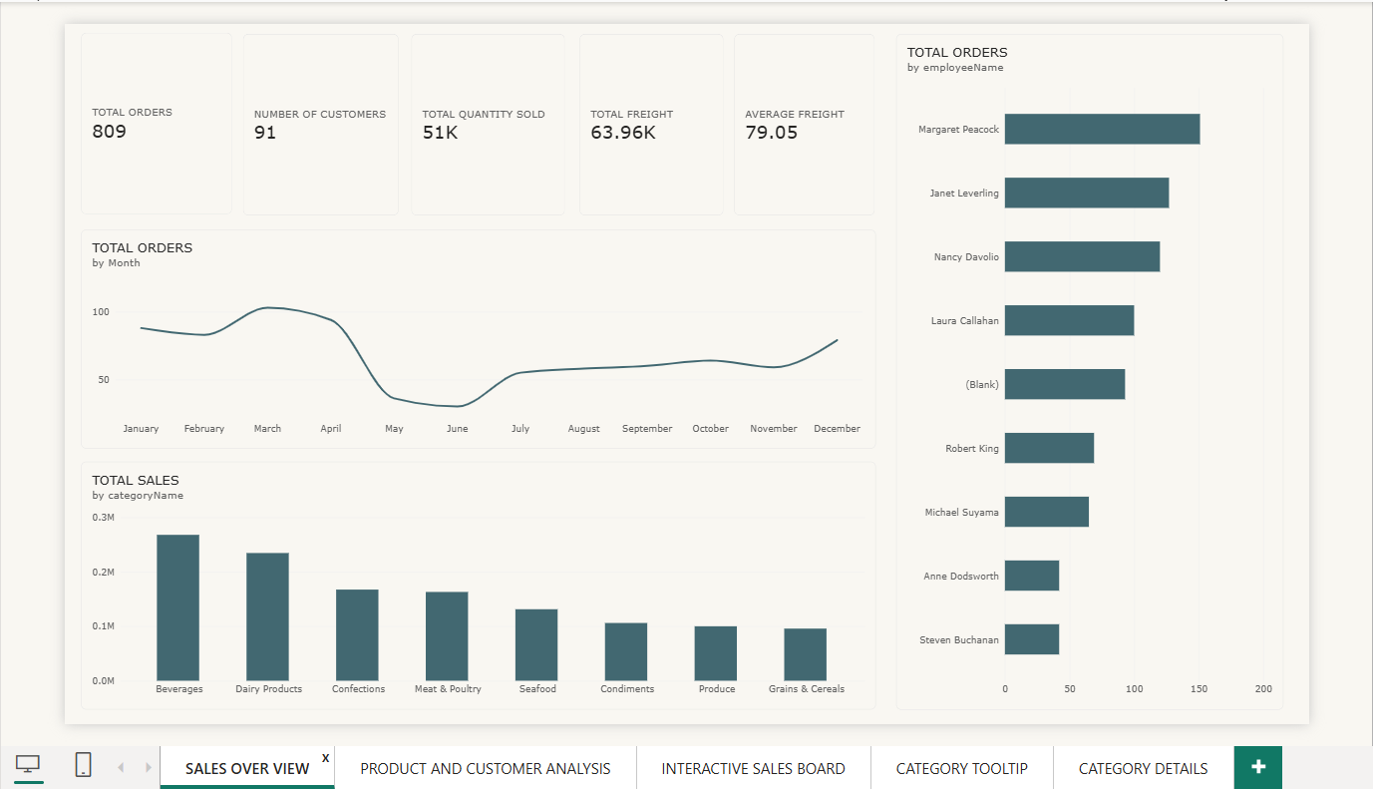

PRODUCT AND CUSTOMER ANALYSIS
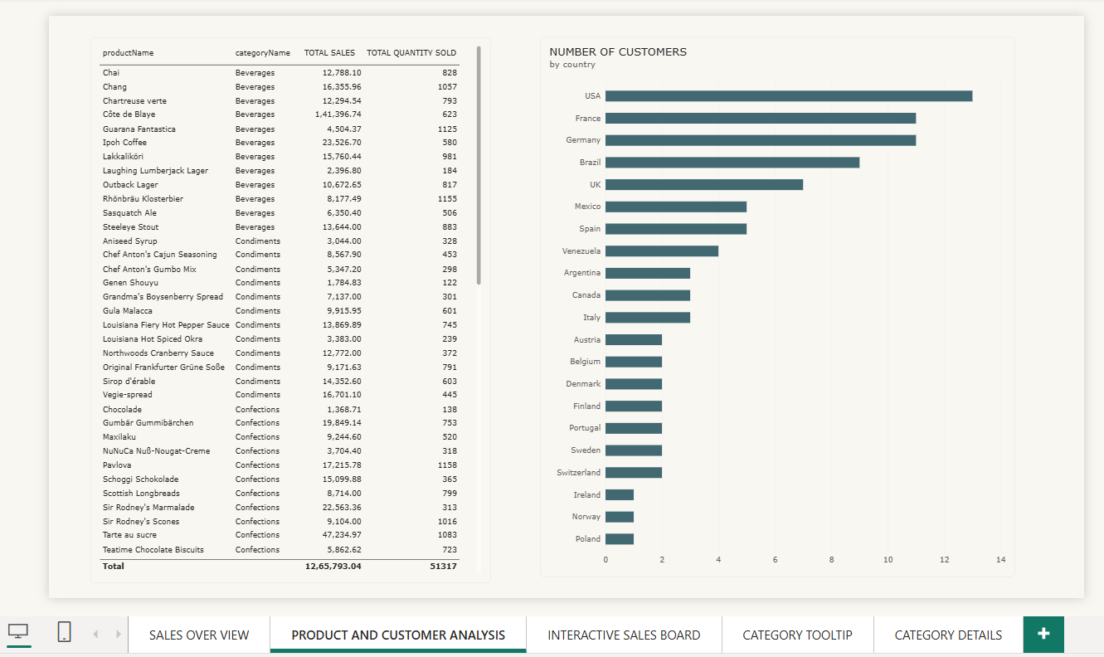
INTERACTIVE SALES BOARD